"Experience the Magic of Kerala”
(4N/5D)

Discover the charm of Kerala and Kanyakumari on this delightful 5 Days / 4 Nights journey through South India's most scenic destinations. Begin in the historic city of Kochi, known for its colonial heritage and vibrant culture. Cruise through the tranquil backwaters of Alleppey, where lush landscapes and traditional houseboats create an unforgettable experience.

Relax on the golden beaches and dramatic cliffs of Varkala, offering breathtaking views of the Arabian Sea. Conclude your journey at Kanyakumari, the southernmost tip of India, where three seas meet in spectacular harmony. Visit iconic landmarks, witness mesmerizing sunrise or sunset views, and soak in the region's rich heritage. Perfect for families, couples, and nature lovers, this itinerary promises the perfect blend of relaxation, culture, and unforgettable memories.

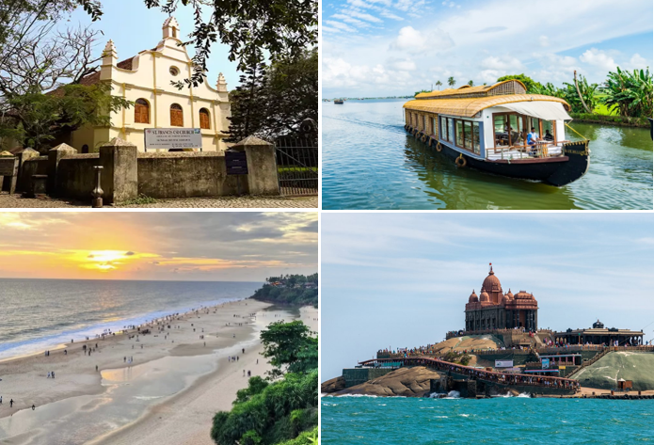

We wish you a happy, safe and unforgettable journey with us

Detailed Itinerary

Day 01: Arrive in Kochi

Upon arrival at Cochin International Airport or Ernakulam Railway Station, meet our representative and transfer to your hotel. After check-in, explore the colonial charm of Fort Kochi, the iconic Chinese Fishing Nets, St. Francis Church, Santa Cruz Basilica, Mattancherry Palace (Dutch Palace), and the historic Jew Town. Spend the evening shopping for spices and local handicrafts or relax at your hotel. Overnight stay in Kochi.

Day 02: Kochi – Alleppey

After breakfast, check out from the hotel and drive to Alleppey, popularly known as the "Venice of the East." Upon arrival, check in to a traditional houseboat or hotel (as per your package). Enjoy a relaxing cruise through the serene backwaters, passing lush paddy fields, coconut groves, and charming villages while experiencing the unique lifestyle of the local people. Savor authentic Kerala cuisine as you unwind amidst the tranquil surroundings. Overnight stay in Alleppey.

Day 03: Alleppey – Varkala
After breakfast, check out and proceed to Varkala, one of Kerala's most beautiful beach destinations. Upon arrival, check in to your hotel and spend the day relaxing at Varkala Beach, famous for its dramatic cliffs, golden sands, and breathtaking views of the Arabian Sea. You may also visit the Janardhana Swamy Temple or explore the lively cliffside cafés and local markets. Overnight stay in Varkala.
Day 04: Varkala – Kanyakumari
After breakfast, check out and drive to Kanyakumari, the southernmost point of mainland India. Visit the iconic Vivekananda Rock Memorial, Thiruvalluvar Statue, Kanyakumari Temple, and Triveni Sangam, where the Arabian Sea, Bay of Bengal, and Indian Ocean converge. In the evening, witness the spectacular sunset over the sea before checking in to your hotel. Overnight stay in Kanyakumari.
Day 05: Kanyakumari – Trivandrum Departure
After breakfast, check out from the hotel and, if time permits, witness the mesmerizing sunrise over Kanyakumari. Later, drive to Trivandrum, with an optional visit to the renowned Padmanabhaswamy Temple (subject to time and temple timings). Proceed to Trivandrum International Airport or Railway Station for your onward journey, carrying unforgettable memories of Kerala's backwaters, pristine beaches, and the enchanting beauty of South India.
Tour ends with unforgettable memories
Destination/Nights | 3* Hotel Name
Kochi /01N
Alleppey /01N
Varkala /01 N | Houseboat
Kanyakumari /01N
HOTELS DETAILS:

Package Cost:

3★ Hotels: Rs. per person (Based on 6 guests – Double Sharing Basis)

Inclusion: -
- Breakfast Included.
- 0 DBL Room on sharing based.
- 03 Nights in Accommodation in hotel.
- 01 Night in Super Deluxe Houseboat in Alleppey.
- All Transfers and S.S tours by AC Vehicle [Pick Up Kochi – Drop at Kochi]
Exclusions: -
- 5% GST.
- Flight Tickets are not included.
- Guide & Extra meal not included or as per the inclusions given above.
- Vehicle not at disposal.
- No extra pickup or drop included for lunch/sightseeing unless otherwise mentioned in the itinerary.

